HTTP Server and Client

Running Code:
- Open the code in two tabs in Spyder.
- Open two separate terminals.
- In the first terminal, run the HTTP server code.
- In the second terminal, run the HTTP code code.

HTTP Server (HTTP_Server.py):

Python Source Code:
from http.server import HTTPServer, BaseHTTPRequestHandler

class SimpleHandler(BaseHTTPRequestHandler):
def do_GET(self):
self.send_response(200)
self.send_header('Content-type', 'text/html')
self.end_headers()
self.wfile.write(b"<h1>Hello from HTTP Server!</h1>")

server = HTTPServer(('localhost', 8000), SimpleHandler)
print("Server running on http://localhost:8000")
server.serve_forever()

Screenshot of Output:
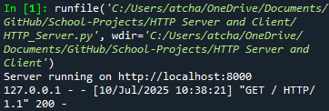

HTTP Client (HTTP_Client.py):

Python Source Code:
import requests

response = requests.get('http://localhost:8000')
print("Status Code:", response.status_code)
print("Response Body:", response.text)

Screenshot of Output:
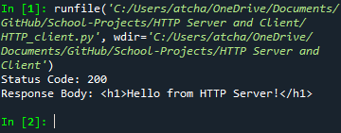

Local Host:
Localhost:8000

Screenshot of Output:
